Art 1010 – Formal Analysis Paper Assignment – Coronavirus Updated (3.12.20)
Professor McCreight
Maura.mccreight@brooklyn.cuny.edu

Papers are Due to my e-mail: maura.mccreight@brooklyn.cuny.edu March 19th, 2020

Description: A TWO-THREE PAGE DOUBLE SPACED 12 point font Times New Roman formal analysis paper includes an analysis of the forms appearing in the work you have chosen. These forms give the work its expression, message, or meaning. A formal analysis assumes a work of art is (1) a constructed object (2) that has been created with a stable meaning (even though it might not be clear to the viewer) (3) that can be ascertained by studying the relationships between the elements of the work. To aid in writing a formal analysis, you should think as if you were describing the work of art to someone who has never seen it before. When your reader finishes reading your analysis, she/he/they should have a complete mental picture of what the work looks like. Yet, the formal analysis is more than just a description of the work. It should also include a thesis statement that reflects your conclusions about the work. The thesis statement may, in general, answer a question like these: What do I think is the meaning of this work? What is the message that this work or artist sends to the viewer? What is this work all about? The thesis statement is an important element. It sets the tone for the entire paper, and sets it apart from being a merely descriptive paper. Use YOUR VOICE. Remember, I want to hear what YOU think – all of the information needed to ace this assignment is in your power and ability to share.

Format for the Paper:
- TITLE
- Introduction paragraph
In the first paragraph, called the introduction, you will include:
•the name of the artist (if known), title (which is underlined or italicized every time you use the title in your paper), date, and medium (if known)
•what you think is the subject
•a very brief description of the work
•thesis statement - usually the last line or so of your first paragraph.

From that point, the rest of the formal analysis should include not only a description of the piece, but especially those details of the work that have led you to come to your thesis. Yet, your paper should not be a random flow of ideas about the work (i.e. stream of consciousness writing). Rather, your paper should have a sense of order, moving purposefully through your description with regard to specific elements. Use my tips below to analyze the artwork. Finally, in your conclusion (the final paragraph) you should end your paper with a restatement of your thesis.

It is important to remember that your interest here is strictly formal; NO RESEARCH IS TO BE USED IN THIS PAPER. In other words, you are strictly relying on your ability to visually ‘read’ a work of art and make interpretations about it based on your analysis of it. Remember too that your analysis should not be just a mechanical, physical description. Please use descriptive language and adjectives to describe your work. Begin with a general description of the work, and then move on to the more specific elements. In addition, please refer to your syllabus concerning my policy on plagiarism – don’t do it! I’ll know if you’re using your own voice.

For Help:
•See Sylvan Barnett’s A Short Guide to Writing about Art – Thesis and formal analysis sections
•I am available to make Skype appointments. Please e-mail me if you’d like to make one.

*TIPS* Key terms to consider when writing a formal analysis paper (in no particular order):
Keep in mind that you always need to Back Up Your Statements!
- Line
- Shape/Size
- Space (see image below)
- Color - bright, intense, naturalistic, dulled
- Texture & brushstroke – smooth, polished, rough, grainy
- Scale
- Emotive Tone
- Overall Composition
- Subject
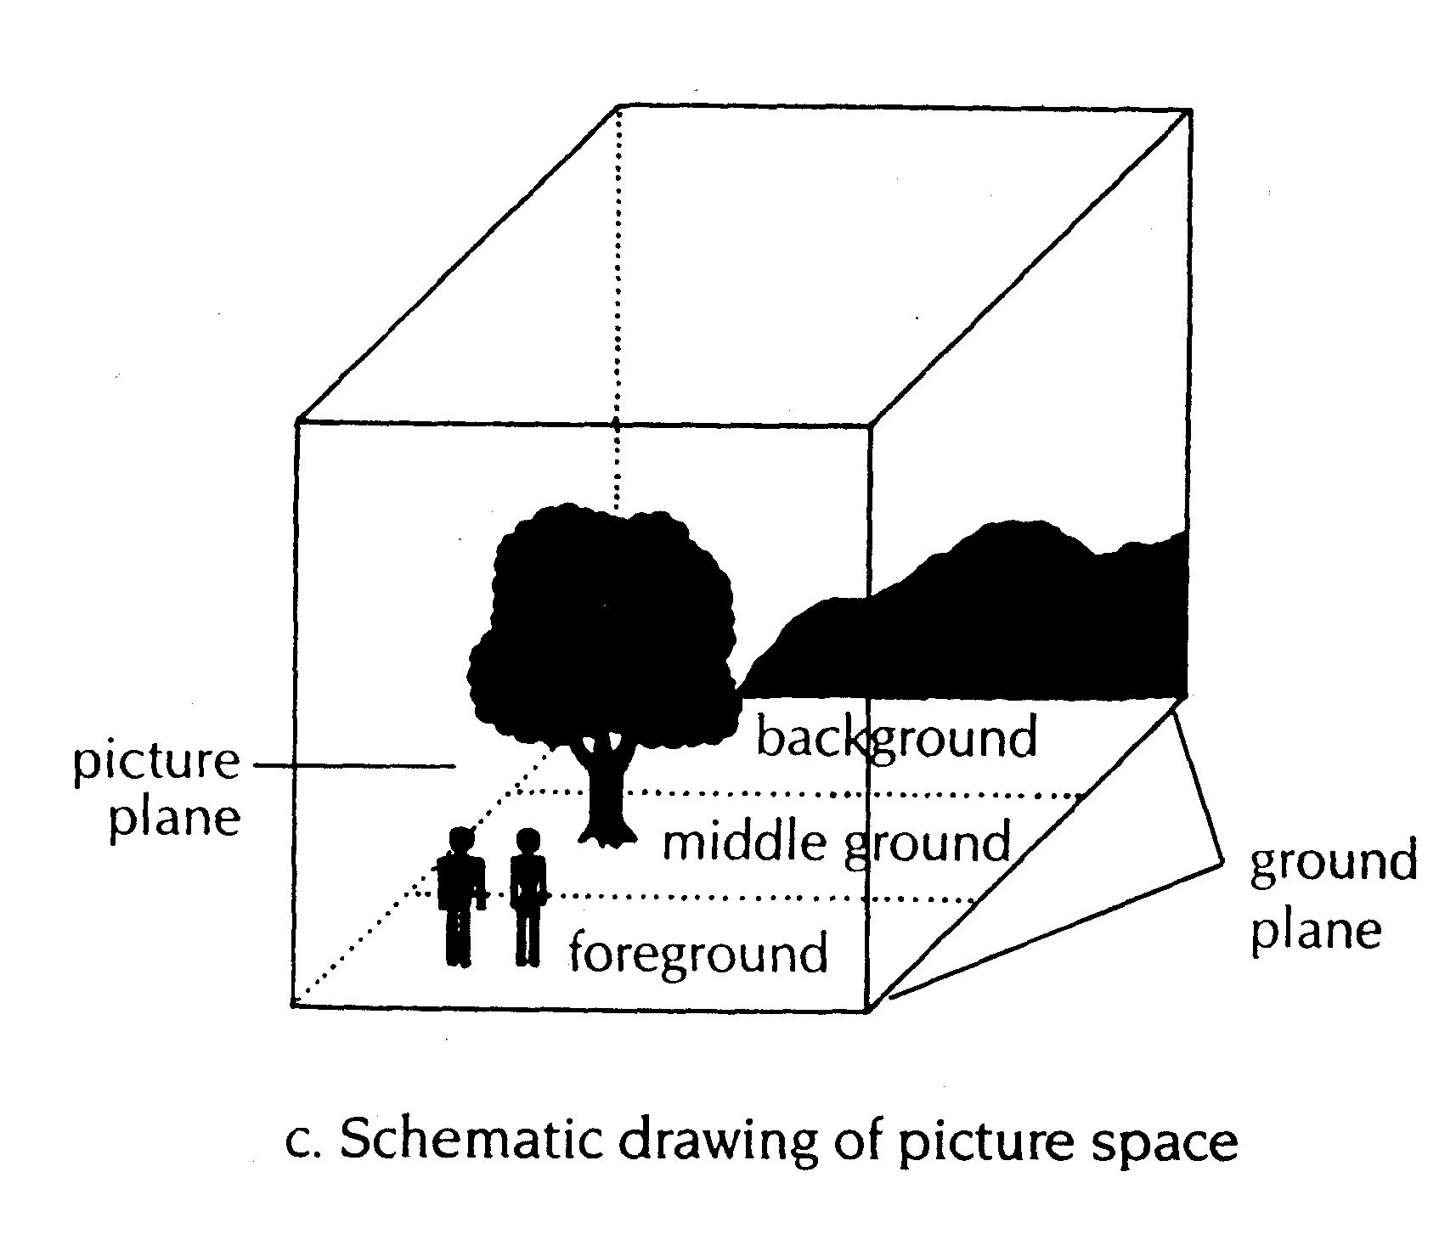

- Record your first impression(s) of the artwork. What stands out? Is there a focal point (an area to which the artist wants your eye to be drawn)? If so, what formal elements led you to this conclusion? Your impressions can help you reach your thesis statement (argument).
- Overall Composition: How are the parts of the work arranged? Is there a stable or unstable composition? Is it dynamic? Full of movement? Or is it static?
- What is the subject of the artwork? Who are the figures? Who does this depict? What does it depict?
- Line: Are the outlines (whether perceived or actual) smooth, fuzzy, clear? Are the main lines vertical, horizontal, diagonal, or curved, or a combination of any of these? Are the lines jagged and full of energy? Sketchy? Geometric? Curvilinear? Bold? Subtle?
- Space: If the artist conveys space, what type of space is used? What is the relation of the main figure to the space around it? Are the main figures entirely within the space (if the artwork is a painting), or are parts of the bodies cut off by the edge of the artwork? Is the setting illusionistic, as if one could enter the space of the painting, or is it flat and two-dimensional, a space that one could not possibly enter?
- Texture: If a sculpture, is the surface smooth and polished or rough? Are there several textures conveyed? Where and How? If a painting, is there any texture to the paint surface? Are the brushstrokes invisible? Brushy? Sketchy? Loose and flowing? Or tight and controlled?
- Scale/Shape: How big is the artwork? Are the figures or objects in the work life-sized, larger or smaller than life? How does the size affect the work? Does the artwork have an usual shape or contain shapes that stand out to you? How would you describe them?
- Light and Shadow: Are shadows visible? Where? Are there dark shadows, light shadows, or both? How do the shadows affect the work?
- Color: What type of colors are used in the work? Bright? Dull? Complimentary? Does the artist use colors to draw your attention to specific areas of the work? How? If a sculpture, examine the color(s) of the medium and how it affects the work.
- Mood/Tone: Do you sense an overall mood in the artwork? Perhaps several different moods? If so, describe them. How does the mood interpret how you view the work? Are there multiple moods in different figures? How would you describe this to someone who has never seen the work?

Object Choices for the Paper (CHOOSE ONE ONLY – this is NOT a comparison essay) – Update: If you opt to do a ‘virtual museum visit’ you must include 2-3 images of one of the objects below

Brooklyn Museum, Asian Galleries, West, 2nd floor

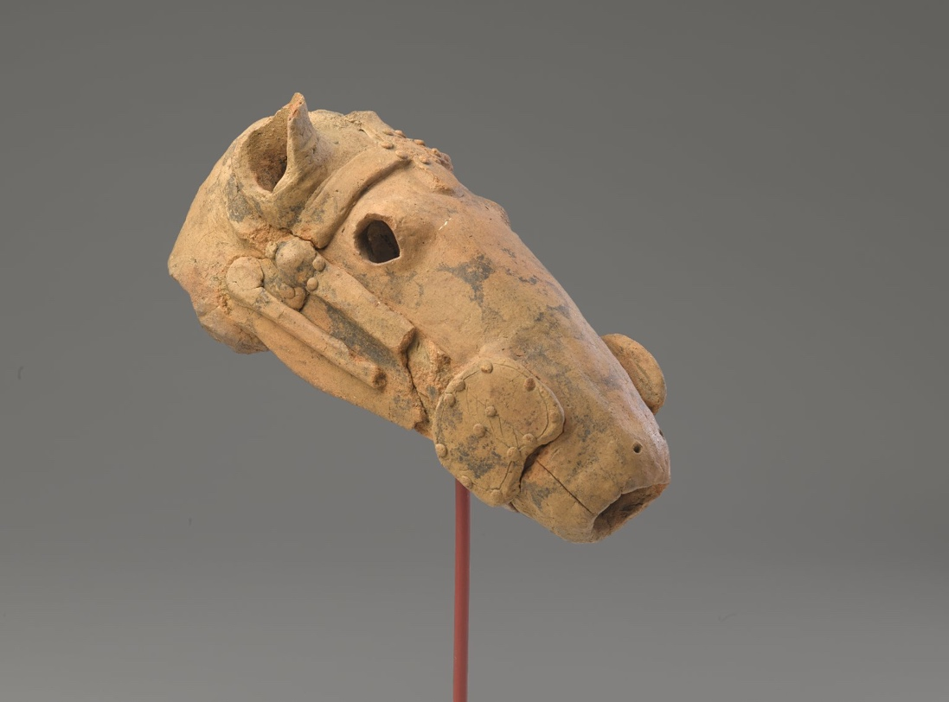

Head from a Haniwa in the Shape of a Horse, 5th-6th century. Low fired earthenware pottery, reassembled from fragments, 6 x 5 1/2 x 12 1/4 in. (15.2 x 14 x 31.1 cm). Brooklyn Museum, Gift of Isamu Noguchi, 61.233. Creative Commons-BY (Photo: Brooklyn Museum, 61.233_PS9.jpg)

Brooklyn Museum, Asian Galleries, West, 2nd Floor

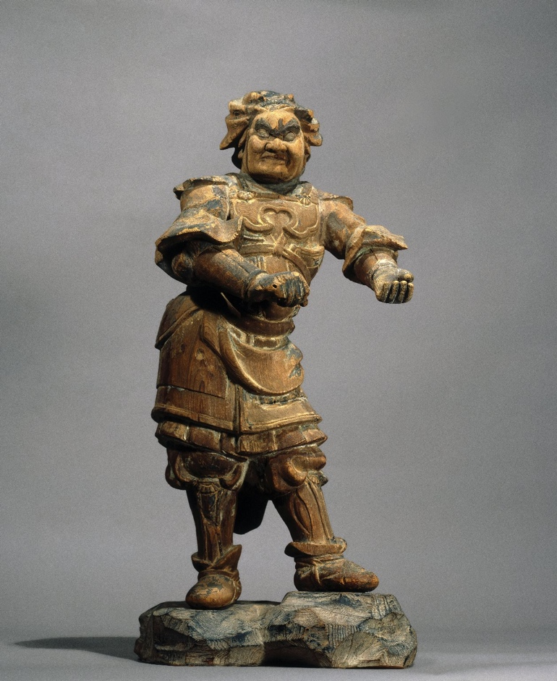
Standing Figure of Buddhist Guardian, 13th-14th century. Wood sculpture with traces of polychromy, 23 7/16 x 11 5/8 in. (59.5 x 29.5 cm). Brooklyn Museum, Carll H. de Silver Fund and Museum Collection Fund, 61.1. Creative Commons-BY (Photo: Brooklyn Museum, 61.1_front_PS6.jpg)

The Metropolitan Museum of Art, on view in The Great Hall (main entrance)
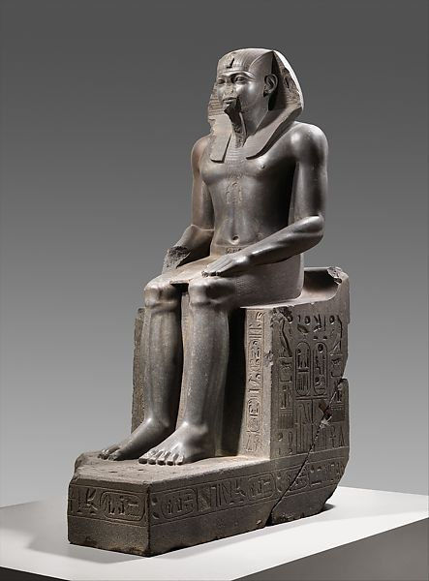

Colossal Seated Statue of a Pharaoh, ca. 1919-1878 B.C.E. H. 320 cm (10 ft. 6 in.); W. 110.5 cm (43 1/2 in.); D. 209 cm (82 5/16 in.) From Egypt, likely Eastern Delta, Tanis (San el-Hagar), On loan from the Staatliche Museen zu Berlin, Ägyptisches Museum und Papyrussammlung (7264).

Metropolitan Museum of Art, on view in Gallery 638
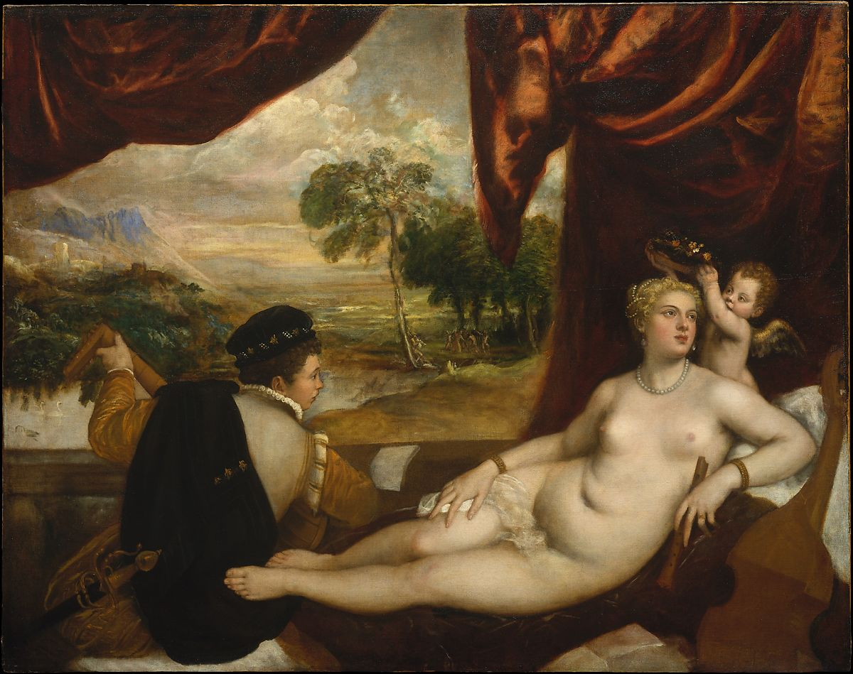
Venus and the Lute Player, Titian (Italian), ca. 1565-70

Modern Museum of Art (MoMA), Floor 4, 401

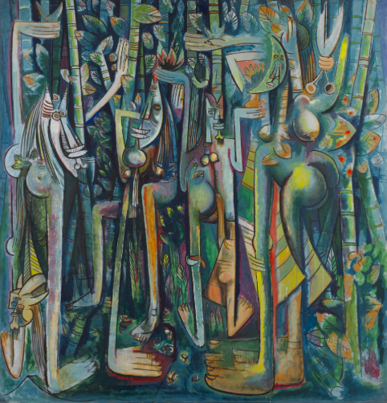
Wilfredo Lam, The Jungle, 1943

Modern Museum of Art (MoMA), Floor 4, 303

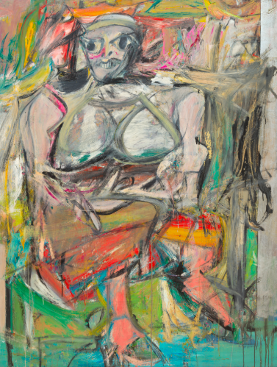
Willem de Kooning, Woman I, 1950–52

